Progressive Education Society's 

**Modern College of Engineering**

**MCA Department**

**A.Y. 2024-25**

**Subject Code: 410908: Data Science Laboratory**

******************************************************************************************** Class: SY MCA Div: B Batch: S1 Roll Number: 51119 Name: Harsh Ghodke Assignment No: 2 Date of Implementation: 20/08/2024 ********************************************************************************************

1 Write a R program to create three vectors a,b,c with 3 integers. Combine the three vectors to become a 3×3 matrix where each column represents a vector. Print the content of the matrix.

Code:

#creating 3 vector

t1<-c(1,2,3)

t2<-c(4,5,6)

t3<-c(7,8,9)

#merging 3 vector into 1

vec<-c(t1,t2,t3)

#creating a matrix

thismatrix <- matrix(c(vec), nrow = 3, ncol = 3)

#giving column names and row names

colnames(thismatrix)<- c("c1","c2","c3")

rownames(thismatrix)<-c("r1","r2","r3")

print(thismatrix)

o/p:

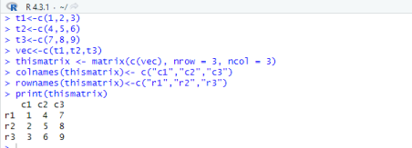

2 Write a R program to create a list containing a vector, a matrix and a list and give names to the elements in the list. Access the first and second element of the list.

Code:

#creating a list

li<-list(c("a","b","c"),matrix(c(1,2,3,4,5,6,7,8,9),nrow=3,ncol=3),list(10,20,30))

#naming list elements

names(li)<-c("vector","matrix","inner list")

print(li[1:2])

o/p:

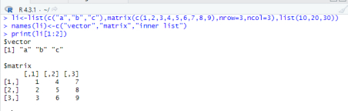

3 Write a R program to create an array with three columns, three rows, and two “tables”, taking two vectors as input to the array. Print the array.

Code:

#combined 2 vectors into a matrix

combined_matrix <- matrix(c(vector1, vector2), nrow = 3, ncol = 3, byrow = TRUE)

#converting a matrix into an array

my_array <- array(combined_matrix, dim = c(3, 3, 3))

print(my_array)

o/p:

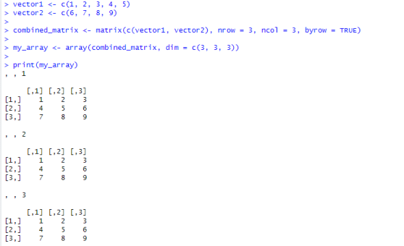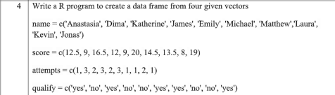Code:

#creating a data frame

four.data <- data.frame(

name=c('Anastesia','Dima','Katherine','James','Emily','Michael','Matthew','Laura','Kevin','Jones'), score =c(12.5, 9, 16.5, 12, 9, 20, 14.5, 13.5, 8, 19),

attempts = c(1, 3, 2, 3, 2, 3, 1, 1, 2, 1),

qualify = c('yes','no','yes','no','no','yes','yes','no','no','yes'),

stringsAsFactors = FALSE

)

print(four.data)

o/p:

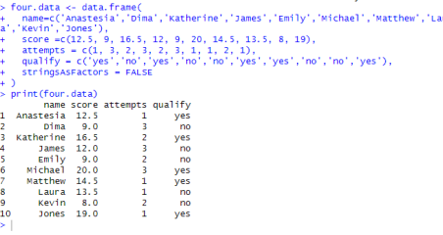

5 Write a R program to create a factor corresponding to height of women data set, which contains height and weights for a sample of women

Code:

heights<-c(160,165,170,155,168,162,175,158,180,150)

weights<-c(55,60,65,50,58,53,70,48,75,45)

gender<-c("male","female","male","female","male","female","male","female","male","female") inp<-data.frame(heights,weights,gender) #creating a data frame

x<-gender

x<-factor(x)#converting a vector into factor

female_data<-inp[inp$gender=="female",] # saving only female data

print(female_data)

o/p:

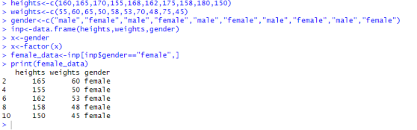

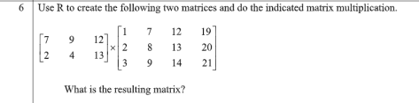

Code:

#creating two matrix

mat1<-matrix(c(7,9,12,2,4,13),nrow=2,ncol=3,byrow = TRUE)

mat2<-matrix(c(1,7,12,19,2,8,13,20,3,9,14,21),nrow=3,ncol=4,byrow = TRUE) print(mat1%*%mat2) #printing multiplication of matrix

o/p:

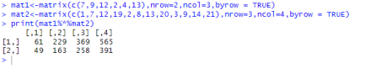

7 WAP to Print the Fibonacci Sequence.

Code:

a=0

b=1

#taking user input

n<-as.integer(readline("Enter num : "));

for (i in 1:n)

{

cat(a," ",b," ")

a=a+b

b=a+b

}

o/p:

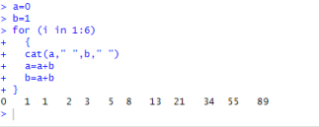

8 WAP to import data in R from csv, excel, txt file.

#reading csv file

x1<-read.csv("D:/manish/csv123.csv")

print(x1)

x2<-read_excel("D:/manish/excel23.xlsx") #reading excel file print(x2)

x3<-read.table("D:/manish/text123.txt") #reading text file print(x3)

o/p:

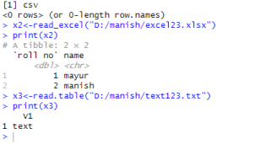

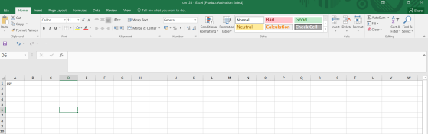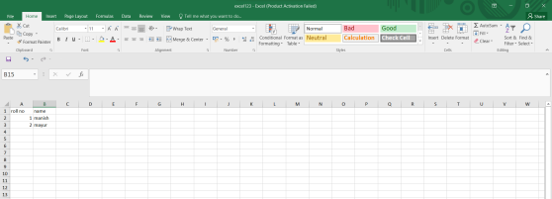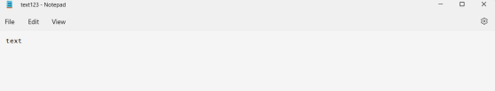9 WAP to export data from R to CSV, Excel, Text File and Google drive.

Rollno <- c("5", "6", "7")

Name <- c("man","may", "adi")

Marks <- c("80", "75", "95")

Age <- c("23", "23", "21")

#creating a dataframe

df <- data.frame(Rollno,Name,Marks,Age)

write.csv(df,"D:\\man\\agedata.csv", row.names = FALSE) #exporting to csv

print ('CSV created Successfully :)')

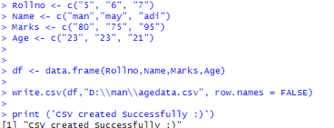



Rollno <- c("5", "6", "7")

Name <- c("man","may", "adi")

Marks <- c("80", "75", "95")

Age <- c("23", "23", "21")

df <- data.frame(Rollno,Name,Marks,Age)

write_xlsx(df,"D:\\man\\agedataexcel.xlsx") #exporting to excel

print ('excel created Successfully :)')

o/p:





Rollno <- c("5", "6", "7")

Name <- c("man","may", "adi")

Marks <- c("80", "75", "95")

Age <- c("23", "23", "21")

df <- data.frame(Rollno,Name,Marks,Age)

write.table(df,"D:\\man\\agetext.txt") #exporting to text

print ('text created Successfully :)')

o/p:



drive_upload('D://man//agedata.csv',type='spreadsheet') # exporting to drive

o/p:





10 Write a R program to create an array of two 3x3 matrices each with 3 rows and 3 columns from two vectors. Print the second row of the second matrix of the array and the element in the 3rd row and 3rd column of the 1st matrix.

Code:

#creating 2 matrix

mat1<-matrix(c(1,2,3,4,5,6,7,8,9),nrow=3,ncol=3,byrow = TRUE)

mat2<-matrix(c(11,12,13,14,15,16,17,18,19),nrow=3,ncol=3,byrow = TRUE)

print(mat1)

print(mat2)

#combing two matrix into an array

arr<-array(c(mat1,mat2),dim = c(3,3,2))

print(arr[2,,2]) #printing array element

print(arr[3,3,1])

o/p:





Code:

#taking user input

cate<-readline("Enter your category : ");

price<-as.integer(readline("Enter Price : "));

#if else for determining category

if (cate=="A") {

print(price*1.08)

} else if (cate=="B") {

print(price*1.1)

} else if (cate=="C") {

print(price*1.2)

}

o/p:



Code:

#taking user input

pur<-as.integer(readline("Enter purchase amount : "))

dis<-as.integer(readline("Enter 1 for Mill Cloth. 2 for Handloom items : ")) var<-""

#if else for determining purchase range

if(pur<=100)

{

var="a"

}else if(pur<=200){

var="b"

}else if(pur<=300){

var="c"

}else{

var="d"

}

if(dis==1) #if else and switch for determining final price

{

switch(

var,

"a"=cat("Final price ",pur),

"b"=cat("Final price ",pur-pur*.05),

"c"=cat("Final price ",pur-pur*0.075),

"d"=cat("Final price ",pur-pur*0.1),

)

}else{

switch(

var,

"a"=cat("Final price ",pur-pur*.05),

"b"=cat("Final price ",pur-pur*.075),

"c"=cat("Final price ",pur-pur*0.1),

"d"=cat("Final price ",pur-pur*0.15),

)

}

o/p:



13 Find Sum of Series 1²+2²+3²+…..+n².

Code:

#taking user input

inp<-as.integer(readline("Enter a number : "))

print(Sum_Square(inp))

#creating a function for finding sum

Sum_Square<-function(inp){

res<-0

for(i in 1:inp){

res=res+(i*i)

}

return(res)

}

o/p:



14 Write a R program to print the numbers from 1 to 100 and print “Fizz” for multiples of 3, print “Buzz” for multiples of 5, and print “FizzBuzz” for multiples of both.

Code:

#using loop and if else to determin type of number

for(i in 1:100){

if(i%%3==0 & i%%5==0){

cat(i," is a FizzBuzz number\n")

}else if(i%%3==0){

cat(i," is a Fizz number\n")

}else if(i%%5==0){

cat(i," is a Buzz number\n")

}

}

o/p:





15 Write a R Program to find the sum of digits of a number reducing it to one digit using repeat loop.

Code:

#taking user input

num<-as.integer(readline("Enter a number : "))

#using repeat loop

repeat{

sum<-0

#finding sum of digits

while(num>0){

sum=sum+num%%10

num=num%/%10

}

num=sum

#condtion to terminate loop

if(num<10){

print(num)

break

}

}

o/p:

